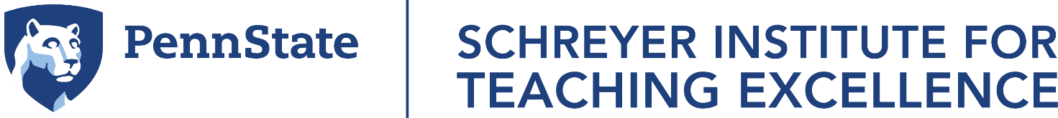

Free events of interest to grad students and postdocs—Spring 2025
You can find detailed information and registration at: https://www.schreyerinstitute.psu.edu/events
If you’d like to schedule a customized event for your department or grad student group, email SITE@psu.edu.
- January 16: Setting the Tone at the Beginning of the Semester: Creating a Welcoming and Inclusive Learning Environment. 2:00-3:00pm on Zoom. Registration.
- January 22: How to Plan a Class Session. 10:10-11:25am on Zoom. Registration. Note: This workshop will also be offered on January 23; pick whichever date works for your schedule.
- January 23: How to Plan a Class Session. 10:35-11:50am on Zoom. Registration. Note: This workshop will also be offered on January 22; pick whichever date works for your schedule.
- January 27: How CIRTL Can Benefit Grad Students and Postdocs. Noon to 12:30pm on Zoom. Registration.
- January 28: An Introduction to Active Learning. 10:35-11:50am on Zoom. Registration.
- January 28: Supporting Wellbeing in Learning Environments. 3:00-4:00pm on Zoom. Registration.
- January 29: Writing Your Teaching Philosophy Statement. 11:40am-12:55pm on Zoom. Registration.
- February 4: Preparing a Teaching Demo for a Job Interview. 10:35-11:50am on Zoom. Registration.
- February 5: Hands-on Workshop: Demystifying Disciplinary Writing Tasks for Our Students. 10:10-11:25am on Zoom. Registration.
- February 14: How CIRTL Can Benefit Grad Students and Postdocs. Noon to 12:30pm on Zoom. Registration.
- February 18: Who? What? How? Why? Strategies for Fostering Curiosity and Wonder in Your Students. Noon to 1:15pm on Zoom. Registration.
- February 19: Designing for Student Engagement. 10:10-11:25am on Zoom. Registration.
- February 24: How CIRTL Can Benefit Grad Students and Postdocs. Noon to 12:30pm on Zoom. Registration.
- April 2: Preparing to Teach a Summer Course. 10:35-11:50am on Zoom. Registration.
- April 10: Syllabus Creation for Grad Students and Postdocs. 10:35-11:50am on Zoom. Registration.
Also consider these short courses: Course in College Teaching (focused on best practices in college teaching; application deadline: January 16); Ethical Pedagogy (focused on inclusive and ethical teaching; application deadline: February 3); and Decoding the Disciplines (focused on ways to teach complex concepts; application deadline: February 21).
If you’d like to chat about topics related to your TAing/teaching or professional development around teaching, set up a free, confidential consultation by emailing SITE@psu.edu. We also have asynchronous resources on Canvas: https://psu.instructure.com/courses/2085646
Penn State is in the 44-university CIRTL Network, and you can pursue various levels of the Penn State CIRTL Teaching Certificate.

